FIRST EXPERIMENT WITH BREADBOARD
LAB FIRST

Group Members: Dipen Gaihre and Lotus Nyaupane Course: Controllers and Electronics
Date: 30.10.2025

Objectives

The purpose of this first lab was to learn how to use a breadboard and make a basic LED circuit.
We connected a red LED and a 100 Ω resistor on the breadboard and attached it to the ADALM1000
(M1K).
Using the PixelPulse2 program, we slowly increased the voltage and measured the current. This allowed us
to draw the LED’s I–V curve.

Theory

A LED is a diode that only turns on when current goes in the forward direction. At low voltage, almost no current flows. When the voltage reaches the LED’s forward voltage (about 1.6–2.0 V for a red LED), the current increases quickly.
The ADALM1000 can give voltage and read current at the same time. PixelPulse2 can make a sawtooth
signal, which slowly increases the voltage. This makes it easier to measure the LED’s I–V curve.

Before the lab, we read these instructions:

  - Lab11 Characteristic Diagram
  - ADALM1000 Introduction
  - PixelPulse2/ALICE software guide
  - How to write a lab report

These guides showed us how to connect the device, use PixelPulse2, and export data.

Equipment, Materials, and Methods Equipment:
  - ADALM1000 (M1K)
  - PixelPulse2 software
  - Breadboard
  - Red LED

  - 100 Ω resistor
  - Jumper wires
  - USB cable
  - Excel

Breadboard Setup:
We made the LED circuit like this:
The long leg of the LED (anode) was connected to the resistor. The short leg (cathode) was connected to ground.

We also took some pictures while doing the experiment.

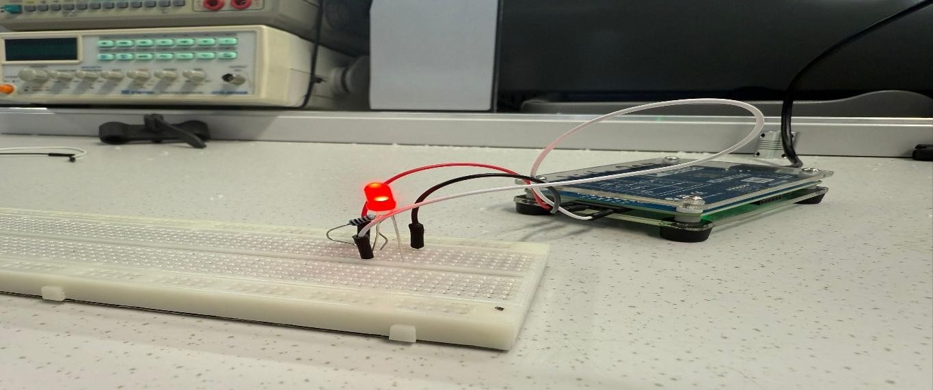

Fig 1: ADALM1000 connected to breadboard with red led light

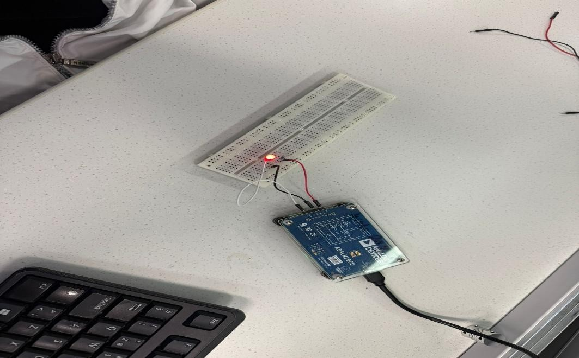

Fig 2: Closeup view of breadboard LED+ Resistor wiring

Measurement Procedure:

  - We connected the ADALM1000 device to the computer and opened the PixelPulse2 program.
  - On Channel A, we chose the option to give voltage and measure the current.
  - From the Z-menu, we picked the sawtooth waveform for the voltage sweep.
  - We ran the voltage from 0 V up to about 5 V to test how the LED reacts.
  - After the measurement, we exported the data into Excel.
  - In Excel, we used Column 1 for voltage and Column 2 for current to make the graphs.
  - We made three graphs: Voltage vs. Current
Voltage vs. LED forward voltage
Column 3 (voltage) vs. Column 2 (current)

We also took a few photos and screenshots while doing the experiment to show the setup and measurements.

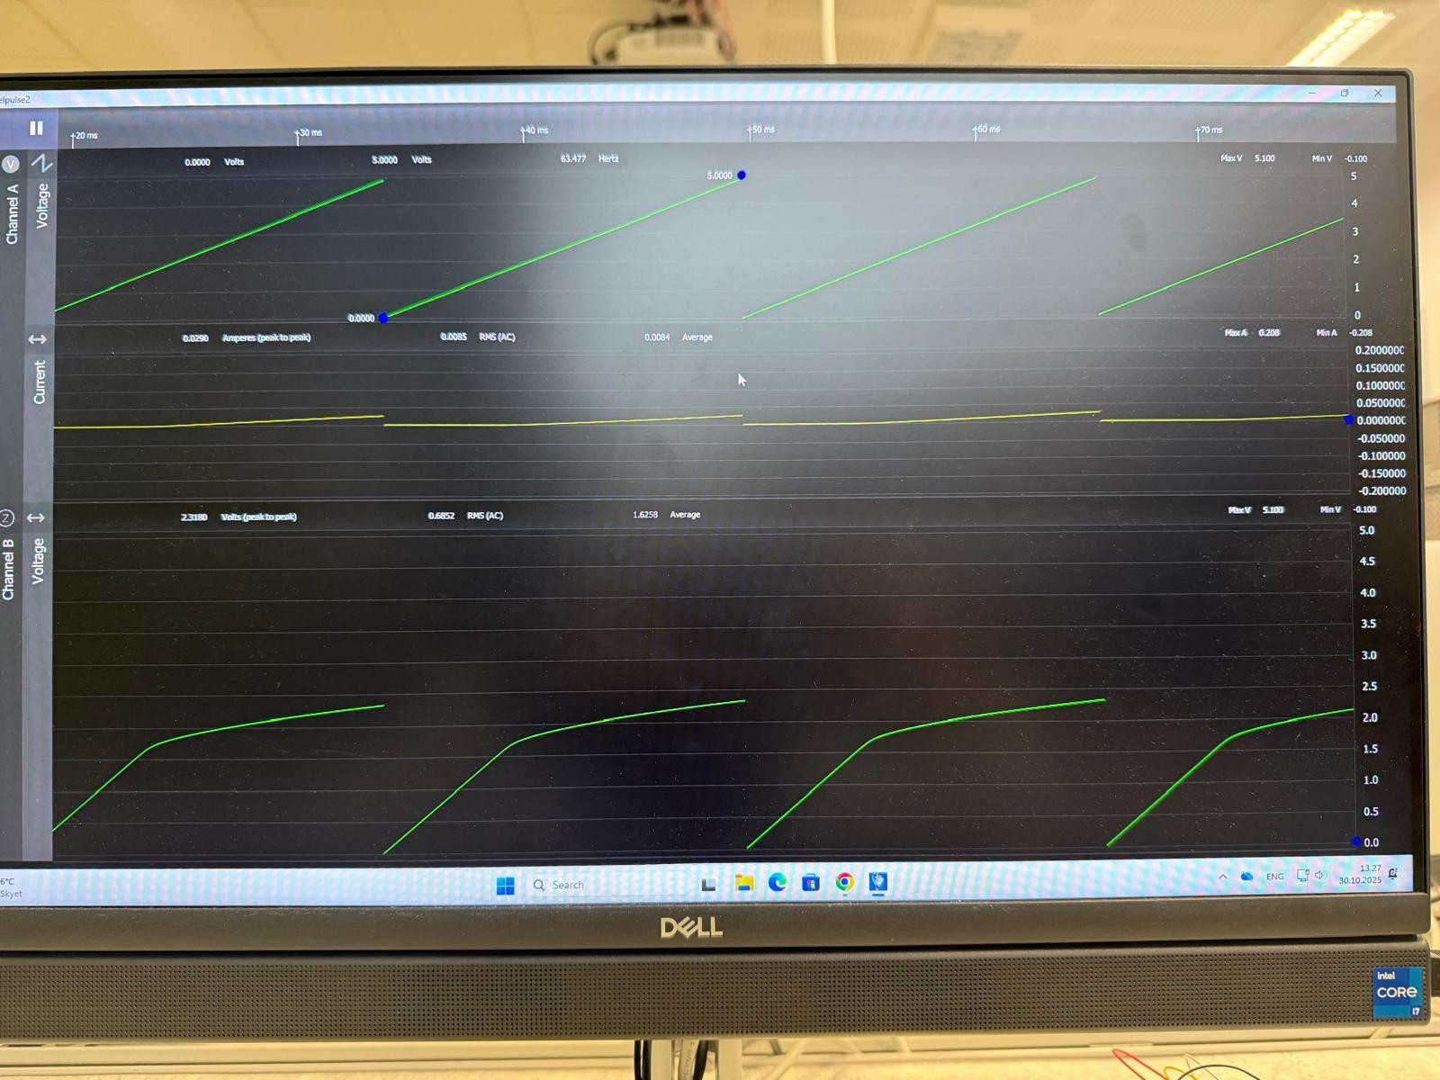
Fig: Pixel plus 2 measurement screen while voltage is sweeping

Results and Analysis Observations:
When we slowly increased the voltage, we noticed that nothing really happened at the beginning. Between about 0 V and 1.5 V, the LED barely let any current through - the values were basically zero.
But once the voltage reached around 1.6 - 1.8 V, the current suddenly started to rise. This is exactly what we expect from a red LED, since they don’t turn on until they hit their forward voltage.

Voltage (V) | Current (A)
3.5397 | 0.0158
3.5716 | 0.0162
0.1682 | 0
4.5221 | 0.0243
4.5110 | 0.0246

The highest current we saw was around 23–24 mA, which is fine because we used a 100 Ω
resistor to keep the current safe.

Forward Voltage (VF)

From both the data and the graph, the LED starts to turn on at roughly:

VF ≈ 1.7–2.0 V

This matches the usual forward voltage range for a red LED.

Shape of the I–V Curve

- The graph we created in Excel showed the typical LED shape:
- The current stays basically flat (almost zero) at low voltages
- Once the forward voltage is reached, the current rises quickly
- The curve makes a clear “knee” shape where the LED starts to conduct
- This “knee” was easy to see in our plotted data.

Possible Sources of Small Error

- There were a few things that could have slightly affected the readings:
- Loose or imperfect breadboard connections
- Noise from the PixelPulse2 measurement
- Tiny differences between LEDs from the factory
- Small changes in the USB power supply
- These are all normal in basic electronics labs and they didn’t change the overall result.

The highest current we saw was around 23–24 mA, which is fine because we used a 100 Ω
resistor to keep the current safe.

Conclusions

In this first lab, we learned how to build a simple LED circuit on a breadboard and how to use the ADALM1000 with PixelPulse2 to sweep voltage and measure current. After exporting the data to Excel, we created I-V graphs and analyzed how the LED behaves.

Our results showed that the red LED turns on around 1.7–2.0 V, which is exactly what theory says. The experiment helped us understand not only how LEDs work, but also how to take measurements and graph them properly.

Overall, this lab gave us good hands-on experience with basic electronics and data analysis.

References:

We took help from AI tools like ChatGPT, our friends, and our teacher for this project.

The End.

